* **What does SAP MM stand for?**

The materials management process involves a few steps beginning from the procurement of materials to receiving materials. The processes include storage and warehousing, transport and receiving. Each of these stages has its own objectives and functions.

**⇒ Purchasing** ⇒ **Storage ⇒ Transport ⇒ Receiving**

* **Types of material management**
* **Inventory Management :** Inventory management aims to strike a balance between the costs of holding too much inventory and the costs of running out of stock.
* **Purchasing Management:** The objective of purchasing management is to buy the required materials at the best possible price and quality while ensuring timely delivery.
* **Warehouse Management:** The goal of warehouse management is to optimize the use of space and minimize the cost of storing and handling materials.
* **Material Requirements Planning (MRP):** is a computer-based inventory management system used to plan production schedules and manage the procurement of materials.
* **Transportation Management:** Transportation management aims to ensure that the materials are delivered on time and at the lowest possible cost.
* **Features of SAP MM (Materials Management):**

SAP MM is a comprehensive module that encompasses various features to facilitate efficient procurement, inventory management, and materials handling within an organization. Here are key features of SAP MM:

1. Procurement Processes:

* Purchase Requisition (PR): Allows users to initiate the procurement process by creating requests for materials or services.
* Request for Quotation (RFQ): Enables the organization to invite quotations from potential suppliers.
* Purchase Order (PO): Facilitates the creation of purchase orders detailing the terms, conditions, and quantities for materials or services.

2. Inventory Management:

* Goods Receipt (GR): Records the receipt of materials into inventory, updating stock levels.
* Goods Issue (GI): Documents the removal of materials from inventory for various purposes like production or consumption.

3. Invoice Verification:

* Three-Way Match: Validates invoices against purchase orders and goods receipts to ensure accuracy before processing payments.
* Vendor Invoice Management (VIM): An extension for automating and streamlining the accounts payable process.

4. Master Data Management:

* Material Master: Central repository containing comprehensive information about materials, including purchasing, sales, and inventory details.
* Vendor Master: Stores information about suppliers and vendors, facilitating efficient procurement.

5. Logistics Execution:

* Warehouse Management (WM): Integrates with SAP WM for advanced warehouse handling and optimization.
* Handling Unit Management (HUM): Manages packaging materials and their tracking during logistics processes.

6. Integration with Other SAP Modules:

* Integration with SAP SD (Sales and Distribution): Ensures seamless coordination between procurement and sales processes.
* Integration with SAP PP (Production Planning): Facilitates planning and execution of production processes.

7. Reporting and Analytics:

* SAP Analytics: Provides a range of reporting tools and analytics for monitoring and analyzing procurement, inventory, and materials data in real-time.

8. User Interface and Accessibility:

* SAP Fiori: Introduces a modern and intuitive user interface for better user experience and accessibility.
* **Objectives Of Material Management**

The following are the five primary objectives of material management:

* **Right Material**

The first objective of material management is to ensure that suitable materials are available for production. It involves identifying the materials required for production and ensuring that they are of the correct quality, specification, and quantity. By ensuring that the right materials are available, companies can minimize the risk of production delays and ensure customer satisfaction.

* **Right Time**

The second objective of material management is to ensure that the right materials are available at the right time. It involves managing the movement of materials within the warehouse, reducing lead times, and improving the efficiency of delivery processes.

* **Right Amount**

The third objective of material management is to ensure that the right amount of materials are available for production. It involves determining the optimal inventory level to maintain and implementing processes to manage the movement of materials within the warehouse. By ensuring that the right amount of materials are available, companies can minimize the risk of stock shortages, reduce the cost of storage and handling, and increase efficiency.

* **Right Price**

The fourth objective of material management is to ensure that materials are purchased at the right price. It involves negotiating with suppliers to obtain the best possible prices and implementing cost-saving measures, such as reducing waste, reducing lead times, and improving the efficiency of delivery processes.

* **Right Sources**

It involves identifying reliable suppliers, [developing partnerships with suppliers](https://www.deskera.com/blog/supplier-management/), and ensuring that materials are purchased from approved suppliers only. By sourcing materials from the right sources, companies can reduce the risk of defective materials, minimize the risk of production delays, and ensure customer satisfaction.

* **Importance of Material Management**
* **Cost Reduction**

Cost reduction can be achieved through effective planning, procurement, and storage processes, as well as through implementing cost-saving measures such as reducing waste, reducing lead times, and improving the efficiency of delivery processes.

* **Improved Quality**

This includes ensuring that the materials and products used in the production meet specified standards of quality and implementing processes to prevent defects.Improving the quality of materials and products can help ensure customer satisfaction, improve the company's reputation, and reduce the cost of rework and warranty claims.

* **Timely Delivery**

This includes ensuring that the right materials are available at the right time and in the right quantity to meet production needs and implementing processes to prevent delays in the delivery of materials. Timely delivery is critical to any business's success and can help improve customer satisfaction, reduce inventory costs, and improve production process efficiency.

* **Inventory Optimization**

This includes determining the optimal inventory level to maintain and implementing processes to manage the movement of materials within the warehouse. Inventory optimization can help to reduce the cost of storage and handling and minimize the risk of stock shortages or obsolescence.

* **Efficient Supply Chain**

A final objective of material management is to ensure the efficiency of the [supply chain](https://www.deskera.com/blog/supply-chain/). This includes reducing [lead times](https://www.deskera.com/blog/lead-time/), improving the efficiency of delivery processes, and optimizing the movement of materials within the warehouse.

* **MM organizational structure**

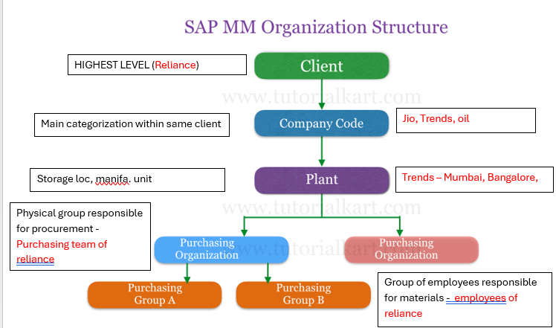

* Client: – It is the highest level of organizational unit that contains a set of tables, master data, etc. In real-time SAP basis consultant [creates new SAP clients](http://www.tutorialkart.com/sap-basis/what-is-client-in-sap-create-new-sap-client/) other than existing clients.
* Company Code: – is a separate legal entity or separate accounting department of an organization. All the financial statements like profit and loss account, business Balance sheets, etc. are prepared at company code level.
* Plant: – is a location where the logistics activities such as production, services and maintenance facilities are performed.
* Purchasing Organization: –is a physical organizational unit which is responsible for procurement of goods and services for an organization from the vendors.
* Storage Location: is the subdivision of plant where the materials are maintained and stored.
* Purchasing Group: – It is a group of people or employees who are responsible with the materials that are being purchased in the organization. Purchase groups are assigned to a respective material master.